May 6th, 2007
Hi
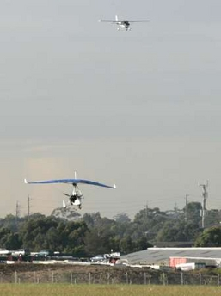
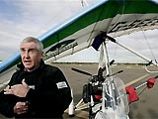
Not very much to write about this week.
Last Monday, a pilot completed a flight in a microlight from London to Sydney. Particularly impressive as be is blind! The man, who was formerly an RAF pilot, was accompanied by a co-pilot and his craft had a lot of high-tech instruments to help. But, nevertheless, he flew it entirely by himself. And on arrival in Sydney, he even did some aerobatics by the harbour bridge.
Well, this past week, exercise settled down into a new pattern. Four types of exercise – skipping, swimming, jogging and weights. For the week, I did three swims for a total distance of 4 km. Every day now, I begin with skipping. So, will probably be doing shorter swims that in past seasons. So, it was strange yesterday to wake up and realise there was no run after 25 consecutive weeks (even though conditions for a run were not bad).
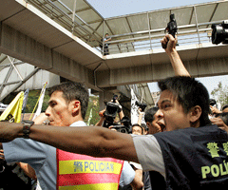
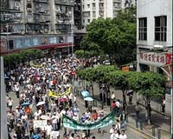
Tuesday was a public holiday for ‘May day’ or Labour Day. In Macau, a protest by workers’, unhappy with low wages and rising housing process, turned into a riot (very rare for Macau) with police shooting into the air. Shrapnel from one bullet hit a passer-by on a motor scooter several hundred metres away! There was a similar protest in HK but it was peaceful.

Gavin, I received your postcard from Santa Clara. I guess by now though, that you are back in Manchester. I note that the postcard was posted from Santa Clara. What were you doing up there? Nadine – we are still waiting for your holiday pictures.
I note from last year’s letter that there were two public holidays in the week – one for May Day and Friday and the other Buddha’s birthday. I see from my calendar that the latter is later in May; it must follow the lunar calendar.
The Super 14 round-robin games were completed this weekend. The top four now play off for the championship. For the first time ever, a South African team finished top of the standings, ahead of the Crusaders who lost at home, their first home defeat for 26 (?) matches.
That’s it for now! Just one page.
Cheers

